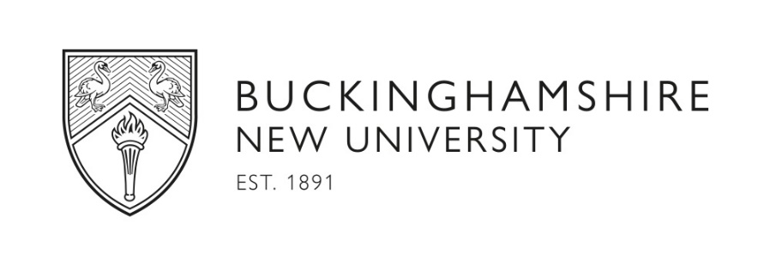

APPLICATION FOR BNU STUDENT AMBASSADOR

Personal Details

Mr/Mrs/Miss/Ms/Other (please specify)

Full Name:

Home Address: | Term Time Address (if different):
Email address: | Mobile No:

Are you currently a student at Buckinghamshire New University Yes No

Student ID Number:

Course title:

Current academic year (e.g., 1st year, Masters etc.):

I confirm that I have no outstanding debts with Buckinghamshire New University or its subsidiary companies:
Yes No

Do you need a Work Permit to work in the U.K? Yes No

Are you a Tier 4/The Student Route Visa student? Yes No

If yes, I confirm I understand that I must not exceed the number of hours stated on my BRP (Biometric Residence Permits) card. Students on a full-time Student or Tier 4 visa are limited to certain time restrictions for the work that they do:
- no more than 10 hours per week in term-time if your course is below degree level (e.g. a Foundation or Pre-Sessional course)
- no more than 20 hours per week in term-time if your course is at degree level.

Signed:

Disability declaration

BNU is a Disability Confident employer. If you have a disability and you would like to declare this disability please select.
Yes No

Do you need any adjustments if shortlisted for interview? Yes No

Name of previous school/ college/ university:

Please provide a supporting statement (2-3 paragraphs) detailing your suitability to the job with reference to the person specification which can be found in the job description. In your answer please include examples and evidence of the skills required for the role.

Declaration:

I declare that the details of this application are correct to the best of my knowledge and, in particular, that I have not omitted any material facts, which may have a bearing on my application.

Signed:

Date:

For recruiting manager to complete

Faculty/Directorate: Marketing, Student Recruitment and Communications

Location: Owen Harris, High Wycombe Campus

To interview Yes No

Date of Interview ……………………………….

